**Problem Statement**

**KPIs Requirement**

Analyze key indicators for our Pizza Sales to gain Business Insight. We are calculating the following metrics:

* Total Revenue: Sum of Total Pizza orders
* Average Order Value: Average amount spent per Order, by dividing Total Revenue/Total number of Orders.
* Total Pizzas Sold: Sum of the quantities of all the Pizzas sold.
* Total Orders: Total number of Orders Placed.
* Average Pizza per Order: Total number of Pizzas sold/ Total number of Orders.

**Chart Requirements**

To Visualize various aspects of Pizza Sales Data to understand the key trends.

* Daily trend of Total Orders – To understand the pattern & fluctuation of Order volume on Daily Basis.
* Monthly trend of Total Orders – Hourly trend of Total order throughout the day.
* Percentage of Sales by Pizza Category – Distribution of sales across different Pizza Categories. To analyze the popularity of Pizza.
* Percentage of Sales by Pizza Size - Distribution of sales across different Pizza Size.
* Total Pizza Sold by Category – Total number of Pizzas sold for each Pizza Category to compare the Sales performance of different Pizza categories.
* Top 5 Best Seller by Revenue, Total Quantity & Total Order – To identify most popular Pizza Options.
* Bottom 5 Worst Seller by Revenue, Total Quantity & Total Order – To identify least popular Pizza Options.

PIZZA SALES SQL QUERIES

1. KPI’s

select * from pizza_sales_excel_file

1. Total Revenue

select sum(total_price) as Total_revenue from pizza_sales_excel_file

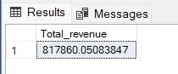

1. Average Order Value

select sum(total_price) / count (distinct order_id) as Average_Order_Value

from pizza_sales_excel_file

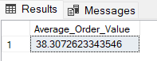

1. Total Pizzas Sold

Select sum(quantity) as Total_Pizza_Sold from pizza_sales_excel_file

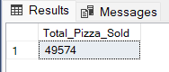

1. Total Orders placed

select count(distinct order_id) as Total_Orders from pizza_sales_excel_file

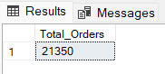

1. Average Pizzas Per Order

select sum(quantity) / count(distinct order_id) as Average_Pizza_Per_Order

from pizza_sales_excel_file

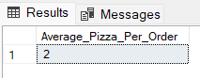

Variations:

select cast (sum(quantity) as decimal (10,2)) / cast (count(distinct order_id) as decimal (10,2)) as Average_Pizza_Per_Order

from pizza_sales_excel_file

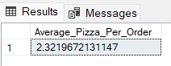

select cast (cast (sum(quantity) as decimal (10,2)) / cast (count(distinct order_id) as decimal (10,2)) as decimal (10,2)) as Average_Pizza_Per_Order

from pizza_sales_excel_file

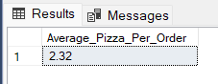

1. Chart Requirements

select * from pizza_sales_excel_file

1. Daily trend of Total Orders:

select DATENAME(DW, order_date) as order_day, count(distinct order_id) as Total_orders

from pizza_sales_excel_file

group by DATENAME(DW, order_date)

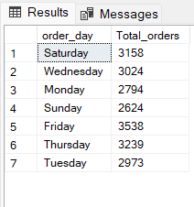

1. Monthly trend of Total Orders:

select DATENAME(MONTH, order_date) as Month_name, count(distinct order_id) as Monthly_Total_orders

from pizza_sales_excel_file

group by DATENAME(MONTH, order_date)

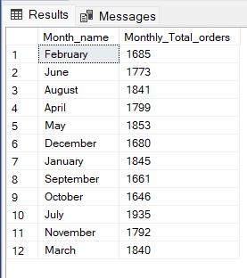

Variation:

select DATENAME(MONTH, order_date) as Month_name, count(distinct order_id) as Monthly_Total_orders

from pizza_sales_excel_file

group by DATENAME(MONTH, order_date)

order by Monthly_Total_orders DESC

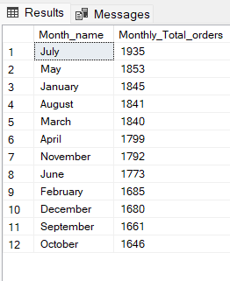

1. Percentage of Sales by Pizza Category:

select pizza_category, sum (total_price) as Total_Sales, sum(total_price) * 100/ (select sum(total_price) from pizza_sales_excel_file) as PCT

from pizza_sales_excel_file

group by pizza_category

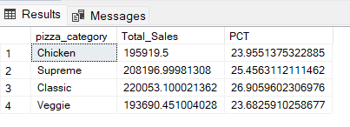

select pizza_category, sum (total_price) as Total_Sales, sum(total_price) * 100/ (select sum(total_price) from pizza_sales_excel_file) as PCT

from pizza_sales_excel_file

where Month(order_date) = 1

group by pizza_category

*\*\*\* Output for the month of January*

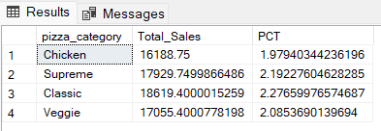

1. Percentage of Sales by Pizza Size

select pizza_size, CAST (sum (total_price) as decimal(10,2)) as Total_Sales, CAST (sum(total_price) * 100/ (select sum(total_price) from pizza_sales_excel_file) as decimal (10,2)) as PCT

from pizza_sales_excel_file

group by pizza_size

order by PCT DESC

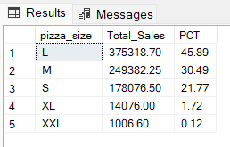

select pizza_size, CAST (sum (total_price) as decimal(10,2)) as Total_Sales, CAST (sum(total_price) * 100/ (select sum(total_price) from pizza_sales_excel_file where DATEPART(quarter, order_date)=1 ) as decimal (10,2)) as PCT

from pizza_sales_excel_file

where DATEPART(quarter, order_date)=1

group by pizza_size

order by PCT DESC

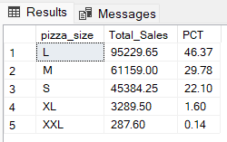

1. Top / Bottom 5 Best Seller by Revenue, Total Quantity & Total Order:

select top 5 pizza_name, sum (total_price) as Total_Revenue

from pizza_sales_excel_file

group by pizza_name

order by Total_Revenue DESC

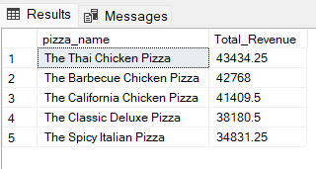

select top 5 pizza_name, cast (sum (total_price) as decimal (10,2)) as Total_Revenue

from pizza_sales_excel_file

group by pizza_name

order by Total_Revenue ASC

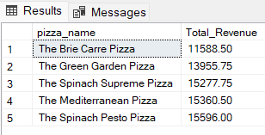

select top 5 pizza_name, sum (quantity) as Total_Quantity

from pizza_sales_excel_file

group by pizza_name

order by Total_Quantity DESC

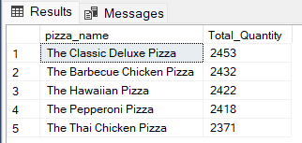

select top 5 pizza_name, sum (quantity) as Total_Quantity

from pizza_sales_excel_file

group by pizza_name

order by Total_Quantity ASC

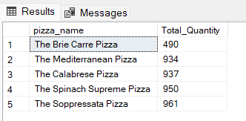

select top 5 pizza_name, count (distinct order_id) as Total_Orders

from pizza_sales_excel_file

group by pizza_name

order by Total_Orders DESC

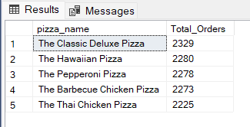

select top 5 pizza_name, count (distinct order_id) as Total_Orders

from pizza_sales_excel_file

group by pizza_name

order by Total_Orders ASC

